 | Activity | Description | Preceding  Activity | Time
A | REQUIREMENT AND ANALYSIS PHASE  - Gather requirements  - Identify hardware & software needs  - Define privacy & security constraints  - Identify user flow and interaction logic  - Create project schedule and assign tasks |  | None | 10  workd ays

System Design Phase
1- Design user interface and user experience
(UI/UX) for the extension  B 2- Design system architecture (AI model → | A | 12
processing → extension UI)
3- Prepare prototypes
4- Review and approval of design
AI MODEL INTEGRATION PHASE
1- Select pre-trained eye-tracking AI model
C 2-Validate model performance and accuracy B 15
- Test model locally
- Ensure privacy (processing on-device, no data storage)

EXTENSION DEVELOPMENT
- Develop browser extension core logic (Chrome/Edge/Firefox)
- Implement UI components for
D popup/settings  - Implement performance optimizations (CPU/GPU usage) | B | 20
Implement AI eye-tracking pipeline inside
the extension • Integration with frontend
TESTING PHASE
- Unit testing (AI model + extension
features)  E • Integration testing (AI + camera + | D, C | 15
extension logic)
- User testing (stability, responsiveness)
- Bug fixing and optimization
DEPLOYMENT & OPTIMIZATION  F • Package and publish extension to Chrome | C | 15
Web Store

G
DOCUMENTATION & TRAINING
- Prepare user guide (how to enable camera, how to use features)
- Prepare technical documentation (AI model, pipeline, architecture)
Submit final documentation
D
35

FINAL HANDOVER
H • Final review meeting and approval
- Handover to stakeholder

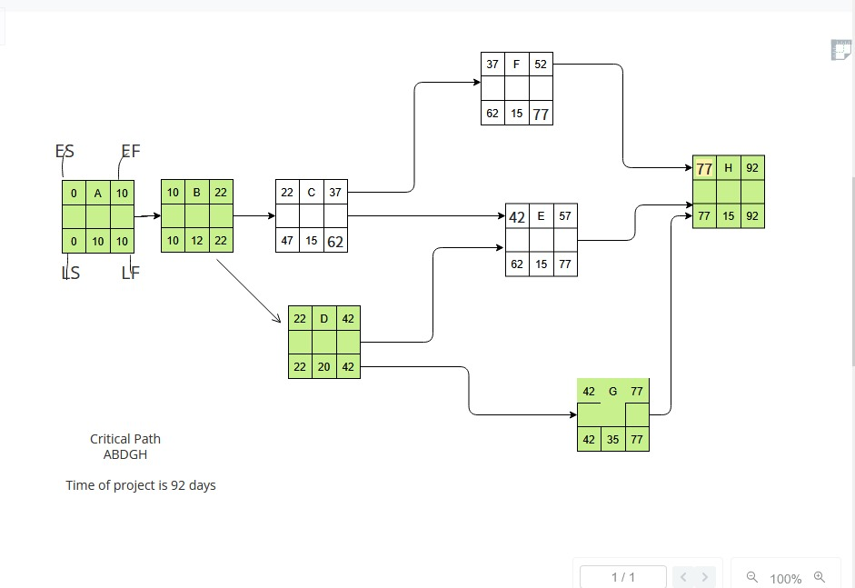
G, F,E 15

